Pir Mehr Ali Shah Arid Agriculture University Rawalpindi
University Institute of Information Technology

Lab Manual

Course Title: | Introduction to Computing |  |  | Course Code: | CS-301
Credit Hours: | 3(2-3) | Class: | BS(CS)(E) | Semester: | I-A/B/C

Lab 1:

Question # 1:

A computer is a device that accepts information (in the form of digitalized data) and manipulates it for some result based on a program or sequence of instructions on how the data is to be processed. Complex computers also include the means for storing data (including the program, which is also a form of data) for some necessary duration. A program may be invariable and built into the computer (and called logic circuitry as it is on microprocessors) or different programs may be provided to the computer (loaded into its storage and then started by an administrator or user). Today's computers have both kinds of programming.
Follow the instructions below:
1. Open a blank MS Word document and type the above text.
2. Copy the last sentence Today's computers have both kinds of programming to the beginning of the first paragraph.
3. Change the typeface of the entire document to 11 point Verdana.
4. Change all the word occurrences of computer to workstation.
5. Change the spacing of the entire document from single spacing to 1.5.
6. Change the alignment of the entire document to Justify.
7. Set the phrases logic circuitry and microprocessors in Italic.
8. Insert a text box and move the whole paragraph into the text box.
9. Fill the text box with Blue color.
10. Create a cover page that precedes the document. Set the title: What is a computer? in 26 point Tahoma, Bold and Center it.
11. Align your name to the bottom right of the cover page in 12 point Tahoma.
12. Save the document as: Computer.doc on the desktop.

Lab 2:

Exercise 1
There are three kinds of lazy dogs:
- Dogs that like to sleep all day
- Dogs that just don't mind foxes jumping over them
- Dogs that have worked hard all day and are now resting.

Follow the instructions below:
1. Open a blank MS Word document.
2. Use page break to type the above text on a new page.
3. Save this document as: MyFirstDoc.doc on desktop.

Exercise 2
Follow the instructions below:
1. Open a new document and type the following memo.
To: Your name
From: Robert Grauer and Maryann Barber
Subject: Microsoft® Word 2003
Date: May 31, 1999
This is just a short note to help you get acquainted with the insertion and replacement modes in Word for Windows. When the editing to be done results in more characters than currently exist, you want to be in the insertion mode when making the change. On the other hand, when the editing to be done contains the same or fewer characters, the replacement mode is best. And when replacing characters, it is most efficient to use the mouse to select the characters to be deleted and then just type the new characters; the selected characters are automatically deleted and the new characters typed take their place.
2. Make the following changes to the text:
a. Select the text Your name and replace it with your name.
b. Replace May 31, 1999 with the current date.
c. Insert the phrase one or in the second line so that the text reads ... one or more
characters than currently exist.
d. Delete the word And from the fourth sentence in the fifth line, then change the
w in when to a capital letter to begin the sentence.
e. Change the phrase most efficient to best.
f. Justify the paragraph.
g. Change the typeface of the entire document

Lab 3:

Type the following page in MS Word
How to Make Brownies
(Recipe Details)

Ingredients
Cocoa | ¼ Cup
Butter | ¼ Cup
Applesauce | ¼ Cup
Sweet 10 – Sweetener (Liquid) | 2 Tablespoon
Vanilla | 2 Tablespoon
Egg (Beaten) | 2 Pieces
Flour | 1 Cup
Salt | ½ Teaspoon
Baking Soda | 1 ½ Teaspoons
Nut (Chopped) | ¼ Cup
Directions
Sift cocoa, flour, salt and baking soda and mix well. Add vanilla, sweetener, eggs. Stir until well-blended and add the dry ingredients. Mix until well-blended, stir in chopped nuts, pour in a greased 8” square pan. Level batter smoothly. Bake at 325 degrees for 20 minutes. Cut into 16 squares.
Nutrition Facts
Calories | 82/gram
Protein | 50/gram
Fat | 1/gram

Tips: According to the chefs of America's Test Kitchen, chocolate deserts such as brownies should be removed promptly from the oven to retain the best chocolate taste. This is because many of the compounds that give chocolate its flavor are highly volatile and easily lost. The smell of brownies cooking is an indication that flavor and aroma are being released into the air. Because they will continue to cook for a few minutes from residual heat, it is best to remove brownies from the oven as early as possible, generally when a toothpick test still shows a few moist crumbs.

Enjoy Cooking!

Lab 3:

Lab 4:

Follow the instructions below:

- Open a new document and create the following tables.



- Add the borders and shading as shown.
- Insert 1 row in between Mathematical Techniques 1 and English.

- Save the document as: Tables.doc on desktop.

Lab 5:
Microsoft Excel

Spreadsheets allows organizing information in a rows and tables (which create cells), with the added bonus of Mathematics and Microsoft Excel is the most extensive application program for creating spreadsheets on the market. Spreadsheets have been used for many, many years in the business to keep track of expenses and other calculations. Microsoft Excel will keep track of numbers you place in cells, and if you define cells to refer to each other, any changes made in one cell will be reflected in these referring cells. It sounds a bit complicated, but MS Excel makes it all breeze.

Opening a Microsoft Excel in Your Computer

To run MS Excel in your computer, go to: “Start” > “Programs” > “Microsoft Excel XP” (for MS Excel 2002) or “Start” > “Programs” > “Microsoft Office” > “Microsoft Office Excel 2003” (for MS Excel 2003). If there is an icon of Microsoft Excel available on your desktop (shaped like a square with “X” in the middle), you can open up the program by double-clicking it, as well. See the following figure for example:

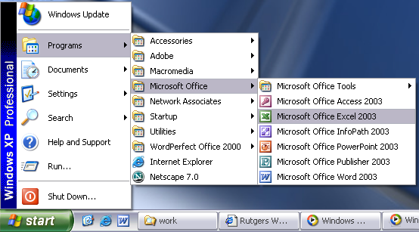

Figure 36. Opening a Microsoft Excel in a Computer

Microsoft Excel will automatically open with a blank spreadsheet spanning many columns and rows. You will notice a number of toolbars with many more options included.

Lesson 1. Getting Familiar with Microsoft Excel

This tutorial teaches Microsoft Excel basics. Although knowledge of how to navigate in a Windows environment is helpful, this tutorial was created for new and advance computer users. To begin, start a new Microsoft Excel worksheet. Then, if necessary, click the “X” in the upper right corner of the task pane to close the task pane.

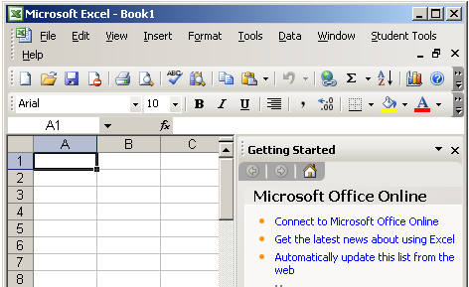

Figure 2.1.1. The Microsoft Excel Environment

The screen shown here will appear.

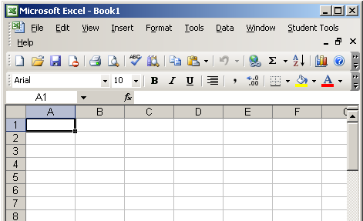

Figure 2.1.2. The Microsoft Excel Environment Without a Task Pane

The Title Bar

Figure 2.1.3. The Microsoft Excel Title Bar

This lesson will familiarize you with the Microsoft Excel screen. You will start with the “Title Bar”, which is located at the very top of the screen. On the Title Bar, Microsoft Excel displays the name of the workbook you are currently using. At the top of your screen, you should see “Microsoft Excel – Book1” or similar name.

The Menu Bar

Figure 2.1.4. The Microsoft Excel Menu Bar

The “Menu Bar” is directly below the Title Bar. The menu begins with the word “File” and continues with “Edit”, “View”, “Insert”, “Format”, “Tools”, “Data”, “Window”, and “Help”. You use a menu to give instructions to the software. Point with your mouse to a menu option and click the leftmost mouse button. A drop-down menu opens. You can now use the Left and Right Arrow keys on your keyboard to move left and right across the Menu Bar. You can use the Up and Down Arrow keys to move up and down the drop-down menu. To choose an option, highlight the item on the drop-down menu and press Enter. An ellipse after a menu item signifies additional options; if you choose that option, a dialog box opens.

Do the following procedure, which demonstrates using the Microsoft Excel menu bar.

- Point to the word File, which is located on the Menu bar.
- Click your left mouse button.
- Press the right arrow key until Help is highlighted.
- Press the left arrow key until Format is highlighted.
- Press the down arrow key until Style is highlighted. Press the up arrow key until Cells is highlighted.
- Press Enter to choose the Cells menu option.
- Point to Cancel and click the left mouse button to close the dialog box.

When using Microsoft Excel, you can set an option to tell Microsoft Excel to always show full menus or to show only the most frequent and recently used options. All the lessons in this tutorial assume you have the menus set to “Always Show Full Menus”. To set your menu to display full menus, do the following procedure.

- Point to the word Tools, which is located on the menu bar.
- Click your left mouse button.
- Press the down arrow until customize is highlighted.
- Press Enter.
- Choose the Options Tab by clicking on it.
- If Always Show Full Menus does not have a check mark in it, click in the Always Show Full Menus box.
- Click Close to close the dialog box.
Lab 6:

Toolbars

Figure 2.1.5. The Standard Toolbar

Figure 2.1.6. The Formatting Toolbar

Toolbars provide shortcuts to menu commands. Toolbars are generally located just below the Menu bar. Before proceeding with this lesson, make sure the toolbars you will use – “Standard” and “Formatting” – are available. Follow the steps outlined below:

- Point to View, which is located on the Menu bar.
- Click the left mouse button.
- Press the down arrow key until Toolbars is highlighted.
- Press the right arrow key.
- Both Standard and Formatting should have a check mark next to them. If both have a check mark next to them, press “Esc” two times to close the menu. If either does not have a check mark, press the down arrow key until Customize is highlighted.
- Press Enter. The Customize dialog box opens.
- Choose the Toolbars tab.
- Point to the box or boxes next to the unchecked word or words, Standard and/or Formatting, and click the left mouse button. A check mark should appear.

Note: You turn the check mark on and off by clicking the left mouse button.

- Point to Close and click the left mouse button to close the dialog box.

Worksheets

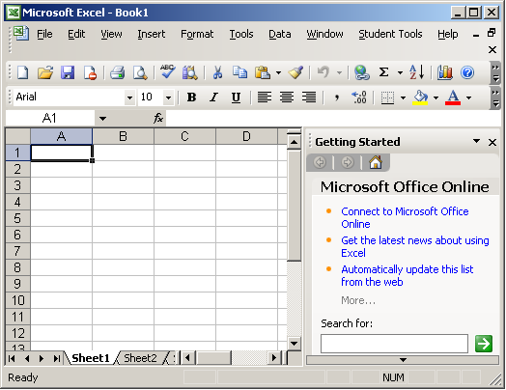

Figure 2.1.7. The Worksheets

Microsoft Excel consists of worksheets. Each worksheet contains columns and rows. The columns are lettered A to IV; the rows are numbered 1 to 65536. The combination of column coordinate and a row coordinate make up a cell address. For example, the cell located in the upper left corner of the worksheet is cell, A1, meaning column A, row 1. Cell E10 is located under column E on row 10. You enter your data into the cells on the worksheet.

Lab 7 & 8:

The Formula Bar

Figure 2.1.8. The Formula Bar

If the Formula Bar is turned on, the cell address displays in the Name box on the left side of the Formula bar. Cell entries display on the right side of the Formula bar. Before proceeding, make sure the Formula bar is turned on. See the following procedure:

- Point to View, which is located on the Menu bar.
- Click the left mouse button. A drop-down menu opens. On the drop-down menu, if Formula Bar has a check mark next to it, the Formula bar is turned on. Press the Esc key to close the drop-down menu.
- If Formula Bar does not have a check mark next to it, press the down arrow key until Formula Bar is highlighted; then press Enter. The Formula bar should now appear below the toolbars.
- Note that the current cell address displays on the left side of the Formula bar.

The Status Bar

Figure 2.1.9. The Status Bar

If the “Status Bar” is turned on, it appears at the very bottom of the screen. Before proceeding, make sure the Status Bar is turned on.

- Point to View, which is located on the Menu bar.
- Click the left mouse button. A drop-down menu opens.
- On the drop-down menu, if Status Bar has a check mark next to it, it is turned on. Press the Esc key to close the drop-down menu.
- If Status Bar does not have a check mark next to it, press the down arrow key until Status Bar is highlighted; then press Enter. The Status bar should now appear at the bottom of the screen.

Notice the word “Ready” on the Status Bar at the lower left side of the screen. The word “Ready” tell you that MS Excel is in Ready mode awaiting your next command. Other indicators appear on the Status bar in the lower right corner of the screen.
Example – Num Lock Key

The “Num Lock” key is a toggle key. Pressing it turns the numeric keypad “On” and “Off”. You can use the numeric keypad to enter numbers as if you are using a calculator. The letters “NUM” on the Status bar in the upper right corner of the screen indicate that the numeric keypad is on.

- Press the Num Lock key several times and note how the indicator located on the Status bar changes.

The “Caps Lock” key is also a toggle key. Pressing it turns the caps function “On” and “Off”. When the caps function is on, your entry appears in capital letters.

- Press the Cap Lock key several times and note how the indicator located on the Status bar changes.

Other functions that appear on the Status bar are Scroll Lock and End. Scroll Lock and End are also toggle keys. Pressing the key toggles the function between “On” and “Off”. Scroll Lock causes the movement keys to move the window without moving the cell pointer. End lets you jump around the screen.
Make sure the Scroll Lock and End indicators are “Off” and complete the following practice exercises.

 Practice Exercise

The Down Arrow Key

You can use the “Down Arrow” key to move downward one cell at a time.

- Press the Down Arrow key several times.
- Note that the cursor moves downward one cell at a time.

The Up Arrow Key

You can use the “Up Arrow” key to move upward one cell at a time.

- Press the Up Arrow key several times.
- Note that the cursor moves upward one cell at a time.

The Tab Key

You can use the “Tab” key to move across the page to the right, one cell at a time.

- Move to cell 1.
- Press the Tab several times.
- Note that the cursor moves to the right one cell at a time.

The Shift + Tab Keys

You can use the “Right and Left Arrow” keys to move right or left one cell at a time.

- Press the Right Arrow key several times.
- Note that the cursor moves to the right.
- Press the Left Arrow key several times.
- Note that the cursor moves to the left.

Page Up and Page Down

The “Page Up and Page Down” keys move the cursor up and down one page at a time.

- Press the Page Down key.
- Note that the cursor moves down one page.
- Press the Page Up key.
- Note that the cursor moves up one page.

The End Key

The “End” key, used in conjunction with the arrow keys, causes the cursor to move to the far end of the spreadsheet in the direction of the arrow.

- Press End key.
- Note that “END” appears on the Status bar in the lower right corner of the screen.
- Press the Right Arrow key.
- Note that the cursor moves to the farthest right area of the screen.

Practice Exercise – Continuation

- Press the End key again.
- Press the Down Arrow key. Note that the cursor moves to the bottom of the screen.
- Press the End key again.
- Press the Left Arrow key. Note that the cursor moves to the farthest left area of the screen.
- Press the End key again.
- Press the Up Arrow key. Note that the cursor moves to the top of the screen.

Note: If you have entered data into the worksheet, the End key moves you to the end of the data area.

The Home Key

The “Home” key, used in conjunction the End key, moves you to cell A1 – or to the beginning of the data area if you have entered data.

- Moves the cursor to column J.
- Stay in column J and move the cursor to row 20.
- Press the End key.
- Press Home.
- You would now be in cell A1.

Moving Quickly Around the Worksheet

The following are shortcuts for moving quickly from one cell to a cell in different part of the worksheet. See the following steps below:
Practice Exercise

Go to – F5

The “F5” function key is the “Go To” key. If you press the F5 key while in Ready mode, you are prompted for the cell to which you wish to go. Enter the cell address and the cursor jumps to that cell.

- Press F5. The Go To dialog box opens.
- Type J3.
- Press Enter. The cursor should move to cell J3.

Go to – Ctrl + G

You can also use Ctrl – G to go to a specific cell.

- Hold down the Ctrl key while you press “G” (Ctrl – G). The Go To dialog box opens.
- type C4
- Press Enter. You should now be in cell C4.

Practice Exercise - Continuation

Name Box

You can also use the “Name” box to go to a specific cell.

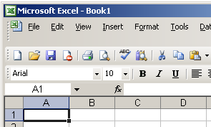

Figure 2.1.10. The Name Box

- Type B10 in the Name box.
- Press Enter. Excel moves to cell D10.

Selecting Cells

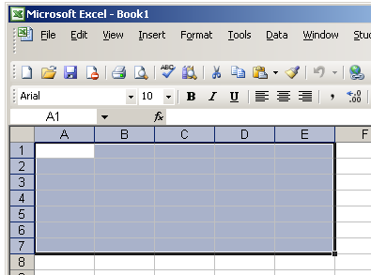

Figure 2.1.11. Selecting Cells A1 to E1

If you wish to perform a function on a group of cells, you must first select those cells by highlighting them. To highlight cells A1 to E1:

- Place the cursor in cell A1.
- Press the F8 key. This anchors the cursor.
- Note that “EXT” appear on the Status bar in the lower right corner of the screen. You are on the “Extend” mode.
- Click in cell E7. Cells A1 to E7 should now be highlighted.
- Press “Esc” and click anywhere on the worksheet to clear the highlighting.

Alternate Method – Selecting Cells by Dragging

You can also highlight an area by holding down the leftmost muse button and dragging the mouse over the area. In addition, you can select noncontiguous areas of the worksheet by doing the following steps:

- Place the cursor in cell A1.
- Hold down the Ctrl key. Do not release it until you are told. Holding down the Ctrl key enables you to select noncontiguous areas of the worksheet.
- Press the left mouse button.
- While holding down the left mouse button, use the mouse to move from cell A1 to E7.
- Continue to hold down the Ctrl key, but release the left mouse button.
- Using the mouse, place the cursor in cell G8.
- Press the left mouse button.
- While holding down the left mouse button, move to cell I17. Release the left mouse button.
- Release the Ctrl key. Cells A1 to E7 and cells G8 to I17 are highlighted.
- Press Esc and click anywhere on the worksheet to remove the highlighting.

Lab 9 & 10:

Entering Data

In this lesson, you are going to learn how to enter data into your worksheet. First, you place the cursor in the cell in which you would like to enter data. Then you type the data and press Enter. See the following procedure below:

- Place the cursor in A1.
- Type “John Jordan”.
- The Backspace key erases one character at a time. Erase “Jordan” by pressing the backspace key until Jordan is erased.
- Press Enter. The name “John” should appear in cell A1. See the following figure for example:

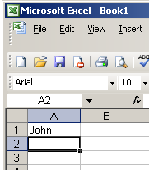

Figure 2.1.12. Entering Data in Cell A1
Editing a Cell

After you enter data into a cell, you can edit it by pressing F2 while you are in the cell you wish to edit. See the following procedure for example:

- Move the cursor to cell A1.
- Press F2.
- Change “John” to “Jones”.
- Use the Backspace key to delete the “n” and the “h”.
- Type “nes”.
- Press Enter.

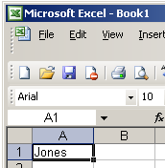

Figure 2.1.13. Modifying an Entered Data in MS Excel Cell

Alternate Method – Editing a Cell by Using the Formula Bar

You can also edit the cell by using the “Formula” bar. You can change “Jones” to “Joker” as follows:

- Move the cursor to cell A1.
- Click the Formula area of the Formula bar. See the following figure for example:

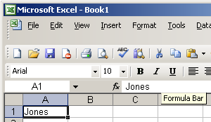

Figure 2.1.14. The Formula Bar

- Use the Backspace to erase the “s”, “e”, and “n”.
- Type “ker”.
- Press Enter.

Alternate Method – Editing a Cell by Double-Clicking in the Cell

You can change “Joker” to “Johnson” as follows:

- Move the cursor to cell A1.
- Double-click in cell A1.
- Press the End key. Your cursor is now at the end of your text.
- Use the Backspace to erase “r”, “e”, and “k”.
- Type “hnson”.
- Press Enter.

Changing a Cell Entry

Typing in cell while you are in the Ready mode replaces the old cell entry with the new information you type.

- Move the cursor to cell A1.
- Type “Cathy”.
- Press Enter. The name Cathy should replace “Johnson”.

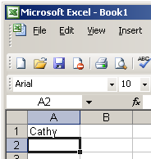

Figure 2.1.15. Changing a Cell Entry

Wrapping Text

When you enter text that is too long to fit into a cell, it overlaps the next cell. If you do not want it to overlap the next cell you can wrap the text.

- Move to cell A2.
- Type “Text too long to fit”.
- Press Enter.
- Return to cell A2.
- Choose Format > Cells from the menu.
- Choose the Alignment tab.
- Click Wrap text.
- Click the “OK” button. The text wraps.

Deleting a Cell Entry

To delete an entry to a cell or a group of cells, you place the cursor in the cell or highlight the group of cells and press “Delete”. See the following procedure for example:

- Place the cursor in cell A2.
- Press the Delete key.

Entering Numbers as Labels or Values

In Microsoft Excel, you can enter numbers as labels or as values. Labels are alphabetic, alphanumeric, or numeric text on which you do not perform mathematical calculations. Values are numeric text on which you perform mathematical calculations. If you have a numeric entry, such as employee number, on which you do not perform mathematical calculations, enter it as a label by typing a single quotation mark first. See the following procedure for example:

Enter a Number:

- Move the cursor to cell B1.
- Type “100”.
- Press Enter.

The number 100 appears on cell B1 as a numeric value. You can perform mathematical calculations using this cell entry. Note that by default the number is right-aligned.

Enter a Value:

- Move the cursor to cell C1.
- Type “100”.
- Press Enter.

The number 100 appears in cell C1 as a label. Note that by default the cell entry is left-aligned and a green triangle appears in the upper left corner of the cell.

Saving a File

This is the end of Lesson 1. To save your file, do the following steps below:

- Choose File > Save from the menu.
- Go to the directory in which you want to save your file.
- Type “Lesson1.xls” in the File Name field.
- Click Save.

Closing Microsoft Excel

Close Microsoft Excel.

- Choose File > Close from the menu.

Lab 11:
Microsoft PowerPoint Overview
When you start MS PowerPoint, it displays the Title Slide in the Slide pane. You can type the title of your presentation and a subtitle on this side. To enter text on the Title Slide:

- Click and type the title of your presentation in the “Click to Add Title” area.
- Click and type a subtitle in the “Click and Add Subtitle” area.

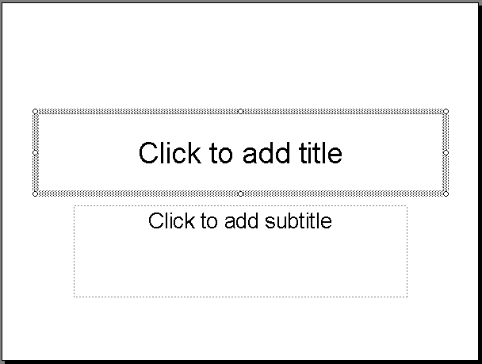
Title Area
Subtitle Area

Figure 3.2.1. The Title and Subtitle Area

If you do not wish to use the Title Slide, choose Edit > Delete Slide from the menu to delete it.

Creating a New Slides

After completing your tile slide, you can create additional slides. To create a new slide:

- Do one of the following:

- Choose Insert > New Slide from the menu. MS PowerPoint inserts a new slide.
- Click the New Slide icon .
- Press Ctrl + M.

The “Apply Slide Layout” pane will appear on the right side of the screen. The Apply Slide Layout pane provides you with slide templates you can use when creating your MS PowerPoint presentation. There are four types of Text Layout Templates, see the following figure for example:

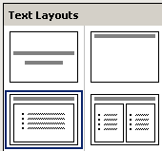
Title
Title and Text
Title Only
Title and 2-Column Text

Figure 3.2.2. The Four Text Layouts in MS PowerPoint

Title Slide - The Title Slide contains two text placeholders that you can use to display a title and a subtitle of your presentation.

Title Only - The Title Only slide contains a single placeholder. You can use it to display a title.

Title and Text - The Title and Text template provides a placeholder for a title and a placeholder for text.

Title and 2-Column Text - The Title and Text template provides a placeholder for a title and two placeholders for text.

- To select a layout, click the Layout you want to apply in the Apply Slide Layout pane. The layout will then appear in the Slide pane. See the following figure for example:

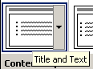

Figure 3.2.3. Choosing a Layout in Apply Layout Slide pane.

- To add text, click inside the placeholder and type.
- To add an additional slide to your presentation do one of the following:

  - Right-click on the slide layout. A menu will appear. Choose Insert New Slide.
- Click the Down Arrow next to the slide layout. A menu will appear. Choose Insert New Slide.
Changing Your Slides

After creating a slide, if you want to add text:

- Place the cursor at the point at which you would like to add text.
- Type the information you want to add.

If you would like to change text:

- Highlight the text you want to change.
- Type the new text.

You can use the Backspace key to delete text. You can also delete text by highlighting the text and pressing the Delete key.

Applying a Design Template

Design Templates provide attractive backgrounds for your PowerPoint slides. To apply Design Templates:

- Do one of the following:

- Choose Format > Slide Design from the menu.
- Click the Slide Design icon .

Design Templates will appear on the right side of the screen.

- To apply a Design Template to all of the slides in your presentation do one of the following:

- Click on the design template.
- Right-click on the template. A menu will appear. Choose Apply to All Slides.
- Click on the Down Arrow next to the template. A menu will appear. Choose Apply to All Slides.

See the following figure for example:

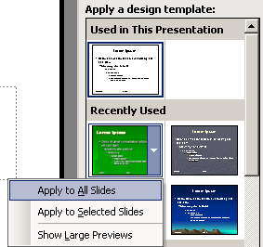

Figure 3.2.4. The Design Template
Correcting a Spelling

Using the PowerPoint Spell Checker, you can check the spelling in your PowerPoint documents. The following procedure demonstrates:

To start Spell Check, do one of the following:

- Choose Tools > Spelling from the menu.
- Press F7.
- Click the Spell Check icon .

If there are possible spelling errors, the Spelling dialog box will open.

Task | Procedure
Do not change spelling. | Click Ignore.
Correct spelling. | - Click the correct spelling in the Suggestions box.  - Click Change.
Add to Dictionary.
Word is correct. Do not change document. | Click Ignore All.
Word is incorrect. Change entire document. | Click Change All.

Sorter View

After you have created your PowerPoint slides, you can move, cut, copy, paste, duplicate, navigate, and view them in Sorter view. To view the slides in Sorter view, do one of the following:

- Choose View > Slide Sorter from the menu.
- Click the Slide Sorter View icon.

See the following figure for example:

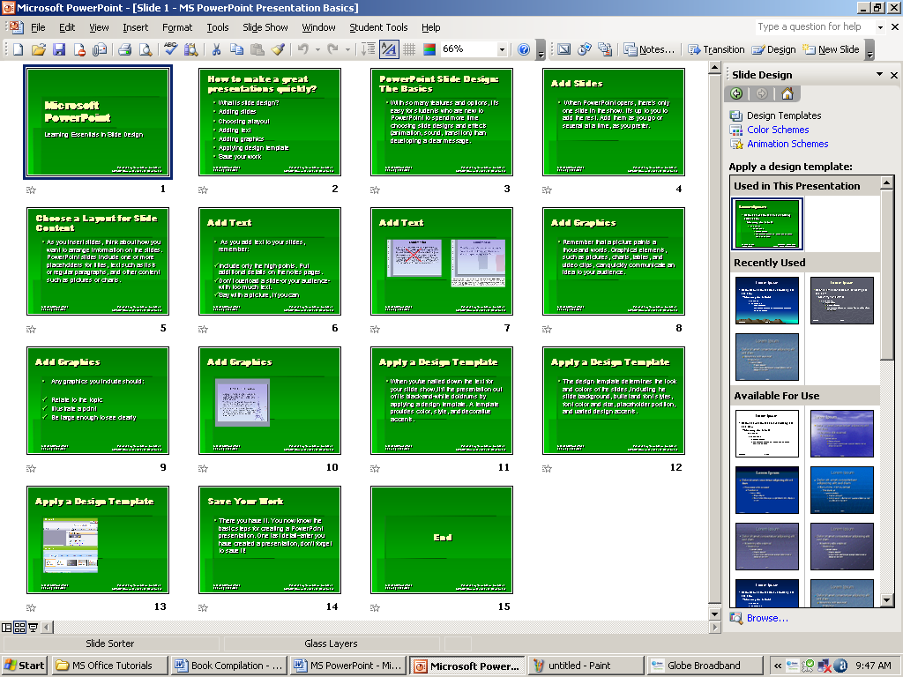

Figure 3.2.4. The Slide Sorted View.
Slide Sorter View
Task | Procedure
Move to first slide. | Ctrl – Home
Move to last slide. | Ctrl – End
Move to next slide. | Right Arrow
Move to previous slide. | Left Arrow
Select a slide. | Single-click slide.
Open slide in Normal view. | Double-click slide.
Select slides. | Select a single slides:  - Click the slide you want to click.  Select multiple slides.  - Hold down Ctrl key.  - Click the slides you want to select.
Delete a slide. | - Select the slide or slides you want to delete.  - Press the Delete key.  Or  - Select the slide or slides you want to delete.  - Choose Edit > Delete Slide from the menu.
Copy a slide. | - Select the slide.  - Choose Edit > Copy from the menu.  Or  - Select the slide.  - Click the Copy icon.  Or  - Select the slide.  - Press Ctrl – C.
Paste a slide. | - Select a slide after which you want the new slide of slides to appear.  - Choose Edit > Paste from the menu.  Or  - Select the slide after which you want the new slide or slides to appear.  - Click the Paste icon.  Or  - Select the slide after which you want the new slide or slides appear.  - Press Ctrl – V.
Cut a slide. | - Select the slide or slides you want to cut.  - Choose Edit > Cut from the menu.  Or  - Select the slide or slides you want to cut.  - Click the Cut icon.  Or  - Select the slide or slides you want to cut.  - Press Ctrl – X.
Move a slide. | - Select the slide or slides you want to move.  - Drag to the new location.
Duplicate a slide. | - Select the slide or slides you want to duplicate.  - Choose Edit > Duplicate from the menu.  Or  - Select the slide or slides you want to duplicate.  - Press Ctrl – D.

Running your PowerPoint Presentations

Once you have created your slides, you can run your Slide Show. Do any of the following:

- Press F5.
- Choose Slide Show > View Show from the menu.
- Click the Slide Show icon , which is located in the bottom left corner of your screen. Your slide will appear on your screen.

Navigating the Slide Show
Task | Procedure
Go to the next slide. | Do one of the following:  - Press the Right Arrow key.  - Press the Enter key.  - Press the Page Down key.  - Left-click.
Go to the previous slide. | Do one of the following:  - Press the Left Arrow key.  - Press the Backspace key.  - Press the Page Up key.
Printing Your Slides

PowerPoint provides you with many printing options. You can print a large view of your slides or you can print your slides as handouts with 1, 2, 3, 4, 6, or 9 slides per page. You can also print your Notes pages or Outline view of your slides.

To print:

- Choose File > Print Preview from the menu. The Print Preview area will open.
- Click the Down Arrow next to the Print What field.
- Select what you would like to print.
- Click the Print icon. The Print dialog box will open.
- Select whether you want your slides to print in color, grayscale, or black and white. If you are using a black and white printer, choose black and white. You will use less ink or toner.
- Check whether you want your slides to print vertically or horizontally.

Lab 12:

Lesson 3. Creating Your First PowerPoint Presentation
The following practice exercise steps you through your first PowerPoint presentation.

Creating a Title Slide

- Start a new MS PowerPoint document.
- Choose Blank Presentation on the Task pane. You will be presented with a Title slide. See the following figure for example:

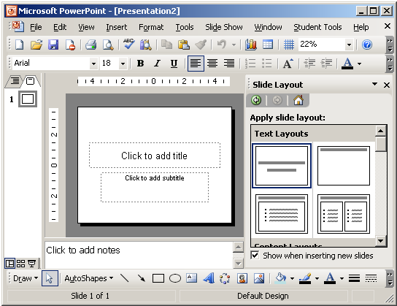

Figure 3.3.1. The New MS PowerPoint Presentation

- Enter the information shown on the following figure below. Type “College Scholarships and Financial Aid” in the Click to Add Title text box. Type “Paying for College” in the Click to Add Subtitle text box.



Figure 3.3.2. Example Data in Title Slide
Inserting a New Slide

To insert new slide in MS PowerPoint, the following steps demonstrate:

- Click the New Slide icon .
- Click the Title and Text icon in Text Layout window on the left side of your screen. See the following figure for example:

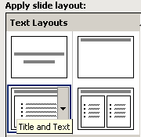

Figure 3.3.3. The Title and Text Layout

- Enter the information shown in the following figure. Type “Here is what to do:” in the Click to Add Title area. Type the bulleted text in the Click to Add Text Area. See the following figure:



Figure 3.3.4. The Second Slide Text

Creating a Hierarchy

The following steps demonstrate.

- Insert a new slide. Right-click the Title and Text icon. A context menu will appear. Choose Insert New Slide from the context menu.
- Enter the information shown on the following figure below. Click the Increase Indent icon to indent the bullets for Stafford Loan and PLUS Loans. If you ever wanted to decrease the indent, use the Decrease Indent icon . See the following figure for example:



Figure 3.3.5. The Text Hierarchy

Using Two-column Text

To create a Two-column Text in MS PowerPoint, the following steps demonstrate:

- Right-click the Title and 2-Column Text icon from the Text Layout. A context menu will appear. Choose Insert New Slide.
- Enter the information show on the following figure below. Type the information in the appropriate column. See the following figure for example:

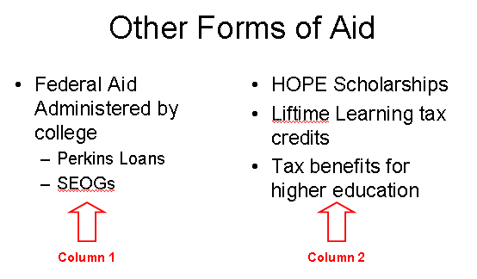

Figure 3.3.6. The Title and 2-Column Text Layout

Applying a Design Template

To apply Design Template in MS PowerPoint slides, the following steps demonstrate:

- Click the Design icon . Design Templates will appear on the left side of the screen.
- Scroll down to view the Design Templates.
- Right-click the Design Template you want to apply. A context menu will appear. Choose Apply to All Slides. Used the Glass Layer design template. See the following figure for example:
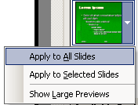

Figure 3.3.7. Selecting a Design Template

Outline and Slides Tab

The following steps demonstrate how to shift in Outline and Slides view:

- Use the Slide tab to view thumbnails of your slide. See the following figure for example:

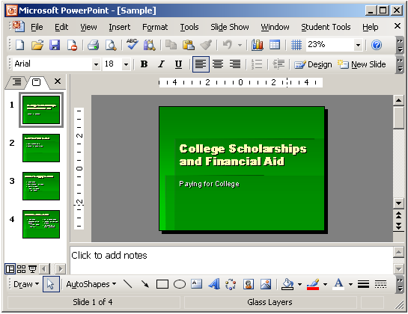
Slide Tab

Figure 3.3.8. The Slide View Tab

- Click the Outline tab to view the text of your presentation as an outline. See the following figure for example:
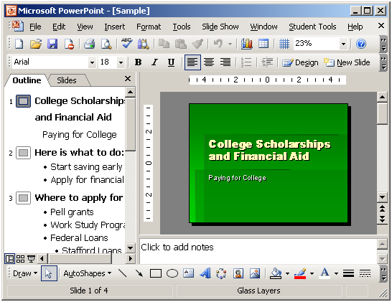
Outline Tab
Figure 3.3.9. The Outline View Tab

The Slide Sorter View

The following steps demonstrate the Slide Sorter View:

- Choose View > Slide Sorter from the menu to move to Slide Sorter view. See the following figure for example:

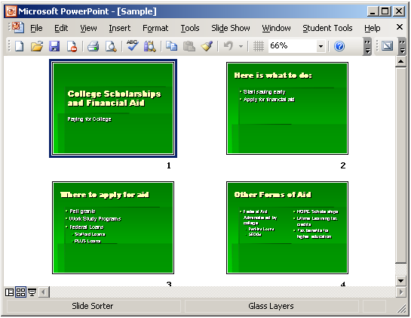

Figure 3.3.10. The Slide Sorter View

- Double-click the slide to return to Normal view.

Running Your Slide Show

The following steps demonstrate the Slide Show view:

- Press F5 key to run the Slide Show.
- Use the arrow keys on your keyboard to move forward and backward through your slides.
- Use Esc key to return to Normal view.

Printing Your Outline

- Choose File > Print Preview from the menu.
- Click the Down Arrow next to the Print What icon. See the following figure for example:

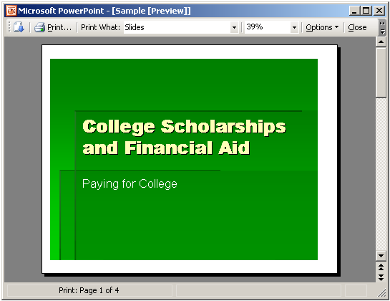
Print What Icon

Figure 3.3.11. Printing Outlines

- Select Outline View.
- Click the Print icon .
- Click Close.

Printing Your Slides

- Choose File > Print Preview from the menu.
- Click the down arrow next to the Print What icon.
- Select the slides you want to print.
- Click the down arrow next to Options. A menu will appear.
- Choose Color/Grayscale > Pure Black and White.
- Click the Print icon.
- Click Close.

Printing Your Slides as Hand-out

- Choose File > Print Preview from the menu.
- Click the down-arrow next to the Print What icon.
- Select Handouts (2 Slides Per Page).
- Click the Print icon.
- Click Close.
This is the end of your MS PowerPoint tutorial and the following pages are your Laboratory Exercises in MS Word, Excel, and PowerPoint.

Lab 13:

MS Access
LIBRARY CATALOG DATABASE
You are a volunteer at a small county library. The library recently received a large collection of young adult books and would like to keep better track of the titles. The library is still using an antiquated method for cataloging most its books. Because of your computer skills, you have been asked to create a database containing the catalog number, title, author and copyright date of each of the new books. The young adult titles database will serve as a model for the library’s entire collection; after it is done, the database will make search, tracking, and inventory functions much easier. Your printed database table should be similar to the one shown here.
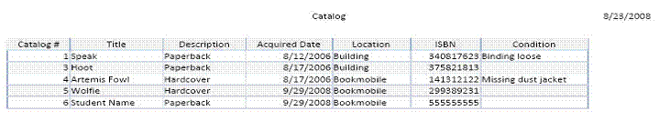
a. Create a blank database named County Library.
b. Add fields using the following field templates from Assets list:
Item
Description
Acquired Date
Manufacturer
c. Switch to Design view. Save the table as Catalog.
d. Edit the Field Properties using the following information:
Field Data | Type | Description | Field Size
Catalog # | AutoNumber
Title | Text | Include complete title | 150
Description | Text | Hardcover or paperback | 15
Acquired Date | Date/Time
ISBN | Number | Unique 10-digit number
e. Add the following new fields:
Field Data | Type | Description | Field Size
Location | Text | Building or Bookmobile | 30
Condition | Memo | Describe condition of book if needed
f. Switch to Datasheet view and enter the following records into the table:
 | Record 1 | Record 2 | Record 3 | Record 4
Title | Speak | Freak the Mighty | Hoot | Artemis Fowl
Description | Paperback | Paperback | Paperback | Hardcover
Acquired Date | 8/12/2006 | 8/12/2006 | 8/17/2006 | 8/17/2006
ISBN | 0340817623 | 0439286069 | 0375821813 | 0141312122
Location | Building | Bookmobile | Building | Bookmobile
Condition | Binding loose |  |  | Missing dust jacket
g. “Best” Fit all column widths.
h. Delete record 2. Add another record with the following data:
 | Record | Record
Title | Wolfie | Enter Your Name
Description | Hardcover | Paperback
Acquired Date | 9/29/2008 | 9/29/2008
Location | Bookmobile | Bookmobile
ISBN | 0299389231 | 0555555555
Condition
i. Check the table in Print Preview. Change the page layout to landscape with wide margins.
Lab 14:
Basic HTML Tags Lesson

Lab 15:

Before starting this set of exercises you must understand the process of editing HTML. The most basic method is to use a simple word processor like Note Pad or Word Pad (found in the Windows Accessories group) or SimpleText for the Mac. Here's the drill:
- Type your HTML code into the editor.
- Save the file (you can do this at any point if you want to view your work). Remember where you save it to.
- View your work by going to your WWW browser and choosing Open File from the File Menu and navigate to your saved html file to view it. When you go back to the editor to make more additions or changes, and then you come back to the browser, you don't need to re-open the page each time. Use the Refresh or Reload Button to get the most recent version of your file.

Basic Tags: Lab Exercise
- Create a simple HTML document about yourself or a topic of your choice using the basic tags learned in the first lesson. (Keep it simple for these exercises. You will be designing a "real" web page later.)
- Save the document as an .htm file and remember where you saved it (name it yournamefile1.htm). If you are using a Mac, you should use the .html file extension.
- Launch your WWW browser. If you are already in your web browser (reading this tutorial!), you may want to open a second browser window.
- View your file in the browser by selecting Open File from the File menu. This may differ somewhat from browser to browser.
- Add bold and italic words to your document, save and view.
- Add a header to your document, save and view.
- Add paragraph and break tags to your document, save and view.
- Add a horizontal rule where appropriate, save and view.

Lists: Lab Exercise
- Add an unordered list to your document, save and view.
- Add an ordered list to your document, save and view.
- Add a definition list to your document, save and view.

Links: Lab Exercise
- Create a new file called yournamefile2.htm (it can be very basic).
- Create a link to Yahoo (http://www.yahoo.com).
- Create a link from yournamefile2.htm to yournamefile1.htm.

Lab 16:

Images: Lab Exercise
- Open one of your HTML files in your editor.
- Add an image to your document using the tag, <IMG SRC="image.gif"> (Note: image.gif is a generic name. Your image may be horse.gif or scenery.gif. Also, the image must be placed in the same directory or folder as your HTML file. Although the image *can* be in another directory, the way to reference that image in your image tag isn't a part of this exercise). Save and view. You can obtain images in several ways:
  - You can save any image off the Internet by clicking on the image (right-click for PC's) and saving it to disk. You can scan an image and save it as a .gif or .jpg file with image editing software.
  - You can create your own images with image editing software.
- Align a short description to the bottom of you image, save and view.
- Align the description to the top of the image, save and view.

Tables: Lab Exercise
- Add a simple table to yournamefile1.htm without borders. Make the table with 2 rows and columns, save and view.
- Add border value of 1, save and view.
- Add a border value of 5, save and view.
- Make the top row a table header, save and view.
- Align all data elements to the middle of their cells, save and view.

Netscape Extensions: Lab Exercise
- Center one of your headers in yournamefile1.htm, save and view.
- Center your image, save and view.
- Align the image to the right, save and view.
- Put a border around the image with a value of 1; save and view each.
- Add a horizontal rule that is aligned to the left, is 50% of the width of the page and has a size value of 5, save and view.
- Give some text (non-header) a font size value of +3, save and view.
- Put a background color and text color on your page. In order to do this you must obtain the hexadecimal value for the color you want to use. Click here to view colors and their associated hexadecimal values. The hex values are at the top of each color swatch (a 6 digit alpha-numeric number). Just plug the value in at the appropriate place in your Body tag.

